### 27th April 2016

### YOKOHAMA Changes Corporate Website Domain

Tokyo – The Yokohama Rubber Co., Ltd., announced today that it has changed the domain for its corporate website to y-yokohama.com, effective 25th April 2016. Going forward, the Company will bring all YOKOHAMA Group websites, with a few exceptions, under this new domain.

■ Corporate website URL

・Before change: <http://www.yrc.co.jp/global/>

・After change: <http://www.y-yokohama.com/global/>

YOKOHAMA’s corporate website has seen an increase in access from users in Japan and around the world, reflecting the Company’s growing global brand recognition, which has been enhanced not only by overseas business expansion but also by its partnership agreement with the Barclays Premier League Chelsea Football Club since July 2015. By integrating nearly all Yokohama Rubber Group websites under the y-yokohama.com domain, featuring the YOKOHAMA corporate logo* at the top of each webpage, the Company aims to further increase the global recognition of the Yokohama Rubber Group. Prior to the change in domain, in March the Company made corporate information on its websites more easily accessible to a worldwide audience by increasing the number of available language web pages. In addition to Japanese and English, the website can now be viewed in Latin American Spanish, French, Simplified Chinese, Arabic, Thai, Korean, Russian, Indonesian, and German, for a total of 11 languages.

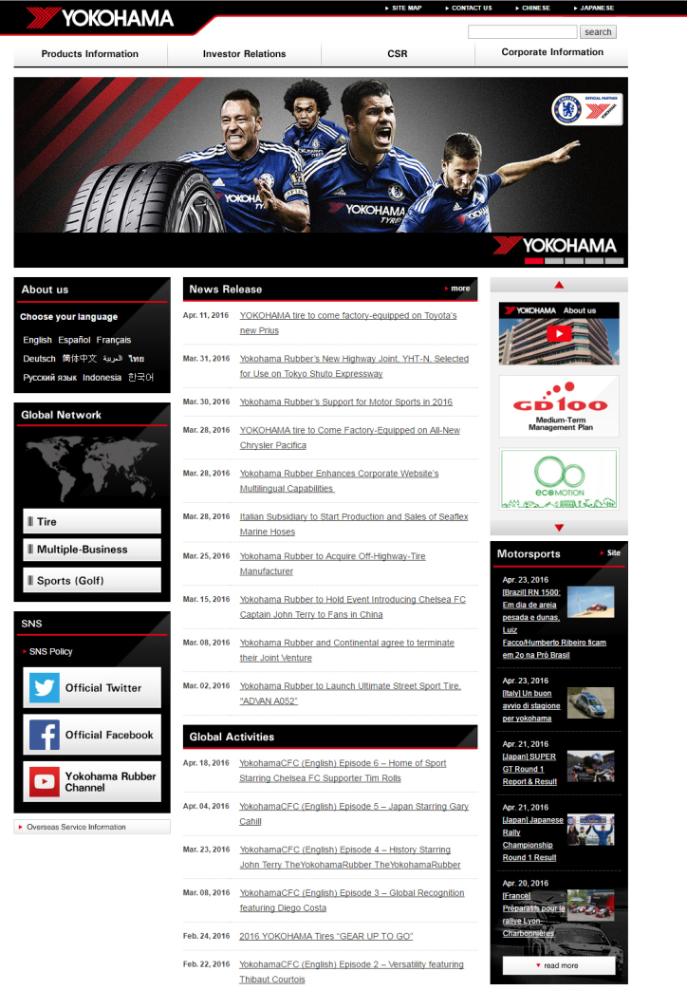

YOKOHAMA’s corporate website